Comprehensive Case Study on Erbil Governorate

Erbil Governorate RCDC; Mohammad Bajilin Center; Rizgary Teaching Hospital; Erbil City Center; Nazdar Bamery PHC; Recommendations

Erbil Governorate RCDC

Iraq has 18 governorates. Currently Kurdistan is the only legally defined Region within Iraq; and Erbil is one amongst the three governorates within the Region of Iraqi Kurdistan. Erbil governorate with a population of 1.6 million has 7 Districts. DOTS strategy in Erbil governorate started in 2000, but the same was interrupted by the war. However, in 2008, with R6 support of GFATM, entire Erbil was covered with DOTS. There are 9 TBMU’s in Erbil with 3 TBMU’s in one district. Out of 211 PHCC’s in the governorate, only 3 provide microscopy services.

Erbil governorate Respiratory and Chest Disease Consultation (RCDC) Clinic has total staff strength of 60 including 4 Doctors, 4 Laboratory Technicians, 3 Pharmacists, 4 Statistician. RCDC caters to about 40-60 new adult out patients per day. In addition to chest symptomatics, the clinic also caters to hotel and other catering staff for their medical examination for which no separate records are kept at the registration desk. All patients including TB suspects have to pay a nominal registration fee of USD 0.4. After registration, all OPD cases are referred to the Doctor who identifies the TB suspects, records them on the patient form and refers them to the surveillance unit. All identified TB suspects are recorded in the suspect register and given a suspect number on the patient form and referred to laboratory for sputum examination, results of which are conveyed to the patient within 24 hours.

About 90% of the patients reportedly come to governorate RCDC because of its reputation of better service provider, and also on account of availability of additional facilities including X-ray. All diagnosed TB patients at RCDC, depending upon their residential address, are referred to the nearest TBMU/ PHCC for getting treatment. Only cases residing in peripheral district are registered in the TB register maintained at governorate RCDC. HIV testing kits have been reported to be in perennial shortage as a result of which all diagnosed TB patients are referred to nearest HIV center for testing and the consolidated monthly report is collected by the governorate. However, no such report could be seen by the evaluation team. No records of cases referred for HIV testing and their reports are maintained by NTP. During April, 2012, out of 6 TB patients referred for HIV testing, results of only 3 patients were available verbally and the HIV status of the patient was not being recorded in the patient treatment card. All smear positive patients are advised to bring their household contacts for evaluation. If the patients do not get the contacts evaluated, no active intervention is undertaken by the health staff.

RCDC receives quarterly report from all its TBMUs within 2 weeks from the end of quarter and a consolidated report of all TBMU’s within the governorate is forwarded to the central level. Neither any analysis of the report is done nor is any feedback on the quality of report and/or performance provided by the governorate to the TBMU making quarterly report a one way process. Internal systems for monitoring and supervision in Erbil though in place lacked commitment to and quality of monitoring was weak. There was no feedback and supervisory meeting discussions lacked instructive information to enhance performance. There was no mechanism for documenting corrective actions to ensure accountability. No quarterly programme review meeting with districts/TBMU has been held for the last one year. Due to financial constraints in 2011, not even one monitoring visit could be made to all the 7 districts. However, in the first quarter of 2012, all districts have been visited once. Monitoring visit schedule is a routine activity unrelated to performance.

The governorate was advised to prioritize low performing TBMU’s for supervision which should not be a mere “visit’ or “policy”. The governorate was advised to hold quarterly review meetings after receipt of quarterly reports which will also provide a platform to the Districts for sharing of mutual experiences. Key indicators of quarterly performance at TBMU levels should be printed as a one pager and regularly circulated amongst all senior officers with in the governorate which will enhance the reputation and morale of good performers and poor performers will struggle hard to get out of the poor performance stigma.

In 2011, 11,173 outdoor patients were registered out of which 980 suspects were identified but diagnostic sputum examinations were undertaken on 1120 suspects detecting 82 smear positive TB cases. From 27 Jan. to 26 April 2012, 3722 outdoor patients were registered out of which 147 were identified as TB suspects but diagnostic smear examination was conducted on 191 suspects out of which 23 were found to be sputum smear positive TB. In the absence of any records to indicate the number of persons coming for medical examination, it’s difficult to comment if adequate screening of OPD patients is being done to identify chest symptomatic. Similarly undertaking of 586 X-ray’s during the same period could not be explained as all cases coming for medical examination were also subjected to an X-ray. Commenting on increased diagnostic sputum examinations when compared with registered suspects, the governorate Director felt that orders to undertake sputum examination only for suspects whose patient card indicates the TB suspect number, needs to be followed religiously. RCDC was advised to keep separate records of the chest symptomatic at the registration desk. Cough symptomatics screening should be conducted at the registration desk or at the patient waiting area, which will help in fast-tracking sputum examination as well as limiting the possibility of nosocomial transmission to other OPD attendants and health facility staff. Non-NTP public and private hospitals need to be systematically involved and a referral policy defined and implemented.

In spite of available diagnostic algorithm booklet, the same was not being adopted by the Doctors. All Pulmonary TB suspects found to be sputum negative were X-rayed without a prior course of antibiotics. In about 14% of cases, no sputum examination was done and the suspects were directly X-rayed and on its findings alone the patients are being initiated on treatment. Such a practice resulting in over diagnosis of cases was well reflected in TB number 6/12 of this center who beyond discontinuation of treatment one week before completion of IP informed the staff that she has stopped treatment because she was wrongly diagnosed. In addition to giving TB treatment to non TB patients, it results in wastage of drugs and lowers the technical credibility of the institution and DOTS strategy.

As on 6th May, 2012, 5 cases were under treatment at governorate RCDC. A perusal of their records revealed that TB number 5/12 and 6/12 had defaulted and no efforts were made to trace them even after 3 weeks of default. As per the existing policy, the health worker waits for about a week after default and thereafter attempts a telephonic contact which quite often fails. In fact TB cards need to be arranged in a manner facilitating defaulter identification at the end of the day of his scheduled visit and enabling the health worker to contact him the same evening. For ensuring against wrong telephone numbers, telephone number given by the patient should be verified by dialing the given number at the time of registration itself. For verifying the correctness of the address, name and address of the VIP in the neighborhood should be recorded. If contact by telephone fails, the patient should be visited at the house for retrieval failing which the support of contact person should be used. A balance between perceived dangers of stigma and transmission of infection to the community by defaulted patient needs to be judiciously maintained not only in the interest of the patient and his family but also in the larger community interest. It is essential to formulate and implement a comprehensive default retrieval policy. To enhance default retrieval skills of the health professionals, enacting “Role plays” should be an important part of the DOTS related trainings.

Some members of the evaluation team along with Director of the governorate RCDC visited one of the defaulters – a female patient with TB number 6/12. Contrary to the perceived perception amongst some of the TB staff, the visit of the team was highly appreciated by the patient and her 12 family members who also included young daughters. It was observed that although the patient ought to have completed IP on 13th April, 2012, still on 6th May, 2 days dosage of IP was still left. The patient was not taking the prescribed dosage and was also splitting the dosage into 3 times a day. During interaction with the patient, yellow coloration of her eyes was observed and was advised to come to Erbil health center next day and also bring all her family contacts for examination. She did comply with both requests the very next day. The team and the Director of Erbil governorate RCDC felt that not undertaking visits for fear of stigma to some extent is a myth and properly motivated patient even easily brings contacts for screening.

To break the stigma barriers, starting from governorate RCDC level “cured TB patient club” need to be formulated because such patients will be an example of normalcy after getting cured from TB. Beyond being effective motivator, cured patients will be very willing workers as they themselves suffered from the carnage of stigma. Since the patient visited by the team was contacted by telephone also shatters the myth that all patients give wrong telephone number.

One of the senior Doctor in Erbil:

“_________But, more important than stigma is discrimination of patients by community, especially health care providers. And this has more effect on patient’s compliance with therapy than the stigma itself. Because when a patient is seeing that a health care provider is avoiding him or her, he will become reluctant to obey their recommendations. And subsequently, he or she will refuse to bring family members for testing and so. ________________we feel strongly that cause of defaults is related to discrimination more than stigma.”

One of the patient diagnosed at the governorate RCDC and taking treatment at the PHC -- a 35 year male bearing TB number 15/2012, is a category II (relapse for the 2nd time). Incidentally his father was a TB patient in 2002 and his sister in 2004 - both in the same clinic. Both were treated for sputum positive TB. This patient was diagnosed for the first time as smear negative TB in 2008 and defaulted from treatment. On his retrieval from default, he was tested to be smear positive and there after he completed his treatment but got a relapse again for which he is presently on treatment. The patient has 2 children out of which one is under 5. From the time of his father getting TB, followed by his sister getting TB and now he himself getting treatment for 2nd relapse, contact examination has never been done because of existing passive method of contact screening. Columns of contact examination in practically all sputum positive cases TB cards were found to be blank. Existing policy of NTP does not depute the health worker to visit patient’s house for contact examination even in cases like TB number 15/2012 who and whose family have never brought the contacts for screening and unfortunately come only when they develop TB. In case the patient does not bring his contacts, it needs to be made mandatory for the health worker to visit contacts of all positive cases at their house for which the health worker may be given the required logistic support by NTP.

Introduction of “Role Plays” covering important DOTS areas like bringing out quality sputum, retrieval of defaulters, explaining treatment details to the patient, importance of contact tracing to all infectious TB patients and their attendants at the time of diagnosis should be included as an integral part of training.

Since there were no patients in the laboratory at the time of the visit, during a mock exercise of the chain of activities in the sputum examination, sputum cups were observed to be labeled on the cap. While working during the day, the laboratory technician reportedly puts a drop of formalin in the sputum cup after drawing the sample and at the end of the day the sputum cups are incinerated. No interim infection control measures from the time of sputum collection through the sputum examination process to the disposal in incinerator were being taken for the used wooden sticks. The center was advised to keep a foot operated bucket in the laboratory and the used sputum containers and wooden sticks should be soaked in the 5% formalin solution in the bucket pending final disposal through incinerator. Incidentally, quality control of this laboratory has also been undertaken and found to be satisfactory.

The clinic reported stockouts of pediatric combination of drugs for last one year and for last one month even INH was reported to be out of stock. Unfortunately, these stock outs continue in spite of repeated communications from governorate RCDC to central level. This situation requires urgent streamlining of drug management system.

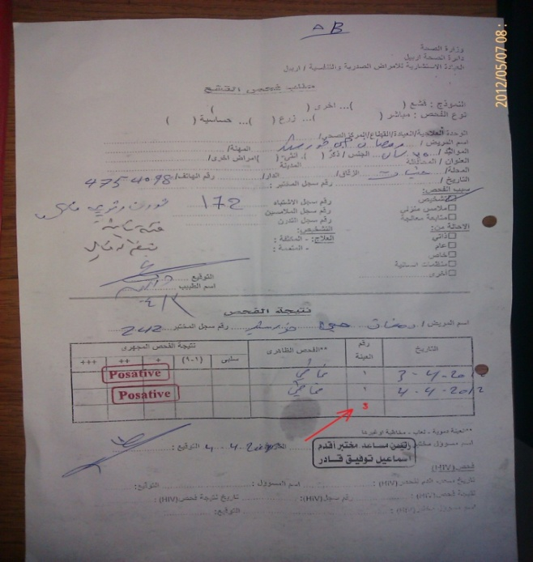
Because of non availability of laboratory forms, the clinic is using old microscopy forms indicating 3 sputum examinations which conveys wrong message to the patient. Shortage of other stationary items was also reported. It was informed that request for supply of TB register, suspect register, laboratory register, contact register, treatment card, identity card, microscopy request form and referral/transfer forms has been pending with SR of GFATM R6/R9 SSF since more than last 7 months.
Old Laboratory Form for Sputum Examination in use

Comprehensive records of all the five cases registered in Q-2/2011 and bearing TB numbers 123,181,221,228 and 534 taking treatment in Erbil governorate RCDC were analyzed, cross checked and correlated with, TB suspect, laboratory register, TB register and the patient treatment card. All the five were NSP cases, out of which 2 have been cured and 3 have completed treatment. There was synonimity in the correlated records except that drug intake in the treatment cards was not properly marked and contact examination column was blank which appears to be universal problem at least in Erbil governorate. In Nazdar Bamery PHC, none of the cards of all the 12 patients under treatment were properly marked nor any contact examination indicated.

It was seen that Rifampacin with 2/3 years shelf life was being used in FDC’s resulting in shorter available shelf life. It is recommended to use only 5 year shelf life Rifampacin. TB No. 133/10 at Mohammad Bajilin center, whose treatment started on 12th April, 2010 was supplied with Pyrazinamide with expiry date of 7/10. The patient defaulted and never came back. If the patient would have restarted the treatment after default, there was always a danger of expired drug having been used. Even otherwise, many expired drugs are still lying in the patient’s envelops placed in the pharmacy with the danger of their being used inadvertently. All expired drugs need to be got removed on priority.

Although overall case detection shows a mixed trend (459 in 2010, 492 in 2011 and 103 in Q1/2012), comprehensive performance of Erbil RCDC has been inching towards improvement since last three years. NSP case detection rate has improved from 17% in 2010 to 26% in Q-1/2012. During the same period sputum smear negative cases have gone down from 42.5% to 26.2%. Against 41.2% cure rate amongst NSP cases in 2010; in 2011 it improved to 69.4% and in Q-1/2012 it has come up to 75%. More than 20% default continues to be an area of concern. These efforts in improving the performance need to be intensified as cases on which diagnostic sputum examination has not been done still remains at more than 11%.

Erbil – CDR

 |  | New | Total | Estimated | Estimated | CDR | CDR
 |  | SS + | New | Number of | Number of | New | new
Erbil CDR | Population |  | Cat.1 | (N.SS+)  25/100.000 | all forms  56/100.000 | CDR NSP | all forms
Y.2009 | 1555778 | 47 | 334 | 389 | 871 | 12% | 38%
Y.2010 | 1555778 | 67 | 440 | 389 | 871 | 17% | 51%
Y.2011 | 1602958 | 83 | 459 | 401 | 898 | 20% | 49%
Q1-2012 | 1602958 | 28 | 94 | 100 | 224 | 26% | 40%
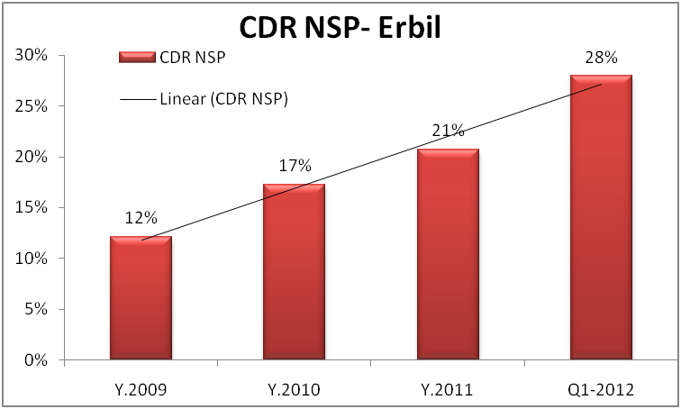
The governorate has not been following the standard cohort analysis pattern in their annual reports. Treatment outcome recorded in annual report of 2011 of Erbil governorate instead of cohort of 2010, includes treatment outcome of 2nd, 3rd, 4th quarters of 2010 and 1st quarter of 2011 as a result of which the figures of indicators differ from the country report. It would be more appropriate if Erbil governorate RCDC also follows the country pattern.

Instead of WTBD message of 2012, messages of WTBD 2010 and 2011 were hanging in a mutilated manner at governorate RCDC, Erbil. No health education material was displayed in any health facility nor was being distributed to the patients or their attendants. The motivation and commitment of the staff towards DOTS was reported and observed to be at a very low level. The staff working in RCDC felt that the DOTS programme “belongs to WHO and UNDP” and they were at a much higher risk of contracting TB. The most immediate requirement for the country is to re-emphasize adopting DOTS as its “policy strategy” for TB control with dedicated commitment for its comprehensive implementation at all levels which requires extensive advocacy by all concerned with a lead from WHO. Likes of Doctor in Erbil governorate who refuses to accept DOTS, LT in Erbil City Center who refuses to perform his duty of sputum examination on account of a self created danger of getting TB while performing his duties or the administrator of Koya District Hospital not wanting DOTS may need to be administratively dealt with. Such a situation in one of the States of India during early days of its DOTS implementation resulted in skyrocketing performance after stringent administrative measures. There is an urgent need of advocacy at governorate level and also to develop a sense of ownership of the programme amongst the staff. Posting in TB clinics are considered to be the “punishment postings”. High turnover of staff was a big concern in Erbil. The government may also consider formulating and implementing a transfer policy.

Comparison of CR, SR & Default rates in Cohorts of 2009, 2010 & 2011 - Erbil

Cohort | New (SS+) | Cured | Completed treatment | Default | Completion +Cure | C.R % | S.R % | Default%
Y.2009 | 47 | 30 | 11 | 6 | 41 | 64% | 87% | 13%
Y.2010 | 67 | 30 | 18 | 16 | 48 | 45% | 72% | 24%
Q1.2011 | 12 | 9 | 0 | 3 | 9 | 75% | 75% | 25%

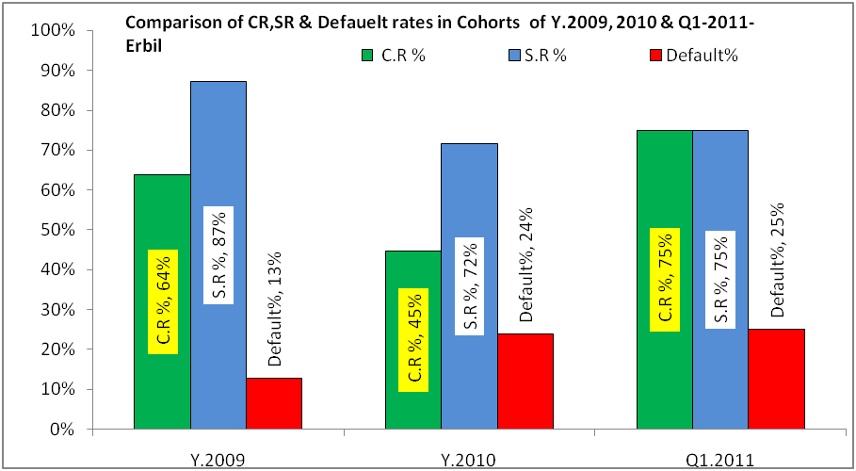

Mohammad Bajilin Center

There are no records to indicate number of patients undergoing treatment at Mohammad Bajilin Center. However, the focal point for TB, estimated that 20 patients are undertaking treatment in the center, but the records of only 12 cases could be made available. Improvised and cost effective arrangement of keeping the patient cards and his complete treatment in a plastic bag with boldly written name of the patient on it was well appreciated both in this center and also in Nazder Bamarny PHC. All the patient treatment cards were examined and following observations are made:

- TB No. 137/10 and 133/10 started the treatment respectively on 14^{th and 12th} April 2010, and both of them defaulted after 1 week. RH expired in 2010 and Z issued to them had an expiry date of 7/10 which had just marginal shelf life if the patients had completed IP of treatment. In fact there was a risk of using expired drugs if the patient would have been retrieved from default

- TB No.53/12 was 25 years female. Sputum examination was not recorded in the card but pulmonary lesions seen in X-ray marked. The patient defaulted after 2 weeks of IP and the drugs were available

- TB NO. 60/12 was sputum smear negative TB 18 year’s female but sputum report was not recorded in the patient card. The patient defaulted after 10 days of IP treatment

- TB NO. 233/09 though category 1, was given 3 months IP and 5 months CP without any recorded reasons

- TB No.214/10 is a 32 years female given IP for 1 month up to 19th July and then CP started on 15th Aug. up to 10th Oct. and patient defaulted. The drugs have already expired in Feb.2011.

Like all other centers, DOT was absent and patients were dispensed medicines through a small space created under the window. All treatment cards didn’t mention the contact examination and marking of TB patient cards has not been up to the mark. TB related health education material was not displayed in the center nor any material was available with the focal point for distribution amongst patients and their attendants. Some batches of drugs used Rifampicin of 2 years shelf life while others had 3 years shelf life resulting in short expiry of the FDC’s. The country should use Rifampicin with 5 years shelf life and for all drugs, the supply should be accepted with the availability of not less than 9/10 shelf life. All expired drugs should immediately be got removed from the health center and no expired drug should be kept in the health center. In the City Center District, the laboratory technician has stopped undertaking sputum examination from April, 2012 and the situation continues in spite of matter being reported to higher authorities. Hospital at Koya District has refused to adopt DOTS and efforts are being made to persuade them.

Rizgary Teaching Hospital

Rizgary teaching hospital is a 486 bedded hospital with staff strength of 500, including 100 doctors of different specialties including 22 physicians. The hospital has a daily adult new OPD attendance ranging from 300 – 350 patients.

Rizgary teaching hospital is one amongst 4 teaching hospitals attached to Medical University Hawleir also known as College of Medicine which is the only medical college in Erbil. The other three attached hospitals include one women and one pediatric hospital. As part of governmental policy, the medical college functions under the administrative control of Ministry of Higher Education while the hospital functions under the administrative control of Ministry of Health.

In April 2011, a physician has been appointed as the focal point to coordinate DOTS activities in the Rizgary teaching hospital. Till date, neither the focal person has been trained in DOTS nor has been briefed about his job responsibilities as the focal point. No DOTS related training/sensitization has been provided to any hospital staff. The pharmacy at the hospital doesn’t function as DOT center. The hospital does not purchase anti - TB drugs and no suspect or referral register is maintained. The hospital neither has any hoardings nor was any TB related education material seen.

Presently some of the clinicians refer their TB suspects to the governorate RCDC for diagnosis and treatment but no records to that effect are being maintained. In some cases, the sputum examination is undertaken in the hospital laboratory, and the result/slide is sent to the governorate RCDC who in such cases examines only one more sputum. During discussions with the focal point and other clinicians it was revealed that prior to 2010; the Rizgary teaching hospital laboratory never reported a sputum positive case. In 2010, because of civil work renovation activities in governorate RCDC, its laboratory was shifted to function from the laboratory of Rizgary teaching hospital. In a unique example of working together, the laboratory staff of RCDC provided hands on supportive training to the laboratory staff of this hospital on sputum microscopy subsequent to which laboratory of Rizgary teaching hospital started detecting and reporting sputum positive cases. During April, 2012, out of a total of 99 sputum examinations conducted in this laboratory, 3 have been detected as positive. On the direction of Erbil Government, governorate RCDC in a recent panel testing of the hospital laboratory sputum microscopy slides had 100% concordance subsequent to which they have been preserving their slides for quality control.

Job responsibilities of the focal point need to be defined. Starting with Doctors medical and paramedical staff needs to be trained in their respective field of operation. All registers and records pertaining to DOTS should be maintained in the hospital. Patient and community focused IEC activities should be undertaken. The laboratory may be designated as a microscopy center from where all suspects attending the hospital can benefit. Similarly the pharmacy of the hospital can function as a DOT center. All these recommended activities should be implemented in all the teaching hospitals attached to all the medical colleges of Iraq.

Most of the clinicians treat TB patients through their own prescription. Because of non availability of anti TB drugs in the hospital, all prescription patients purchase their ant TB drugs from the market where sale and storage of anti TB drugs (H, R, Z, E, Inj. SM) has been banned by the Government since 2011. To understand the ground reality, the team leader decided to have firsthand information of the effectiveness of the ban order which would throw light on the manner in which patients are able to procure prescribed anit TB treatment. One national member of the evaluation team who is a Doctor wrote three anti TB first line drugs prescriptions in the name of pseudo patients. To give the prescription a technically sound look, tablet Pyridoxin was also included. Three members of the evaluation team were briefed by the team leader on the methodology to be adopted while visiting pharmacies as a potential customer. To get a sufficiently representative assessment, each team member was required to visit at least 6 pharmacies ensuring that no pharmacy was visited by more than one team member. There was no difficulty in identifying 18 pharmacies as there are around 75 pharmacies in popularly known as “Doctors Street” in the heart of Erbil. Accordingly 18 pharmacies were visited by three members holding one month prescription for H, R, Z, E, Injection SM and Vitamin B6. Rifampacin was available in 94.4% pharmacies, INH in 38.9%; Ethambutol in 33.3%; Injection SM in 100%; and Tablet B6 in 83.3% pharmacies.

It is an outstanding achievement for NTP for motivating the Government to ban storage and sale of anti TB drugs in the private pharmacies. However, an ineffective ban order relating to sale of anti TB drugs is much more dangerous than “free sale of anti TB drugs” because ineffective implementation leads to proliferation of non standard combination of “whatever, whichever, wherever and whenever” available anti TB drugs which become the churning source of MDR-TB necessitating effective implementation of the ban.

Evaluation team reiterates its opinion that adoption of DOTS strategy in the teaching hospitals has to precede the introduction of DOTS in the teaching curriculum of medical schools. In fact, a well adopted DOTS strategy amongst the clinicians in the teaching hospital would automatically pave the way for introduction of DOTS in the teaching curriculum of medical schools.

Erbil City Center

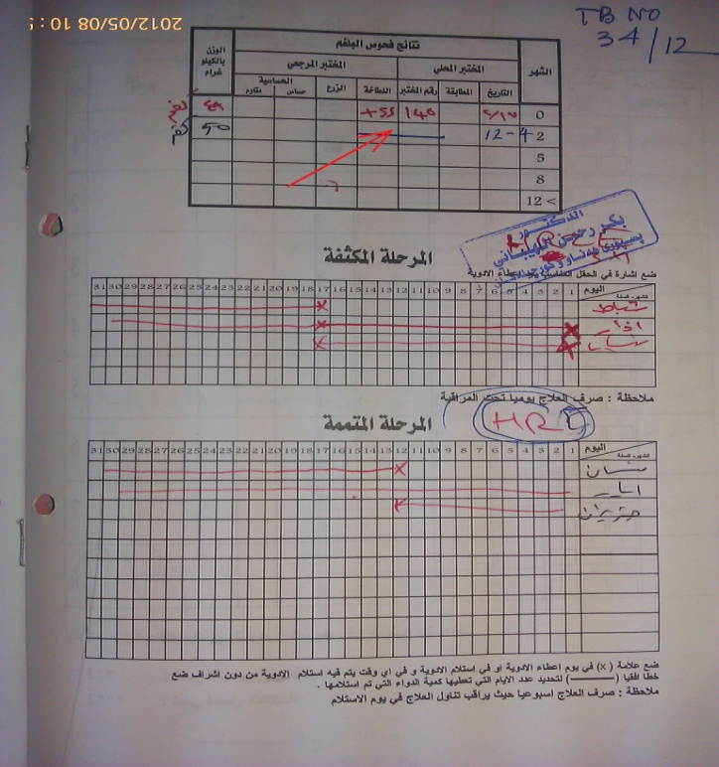
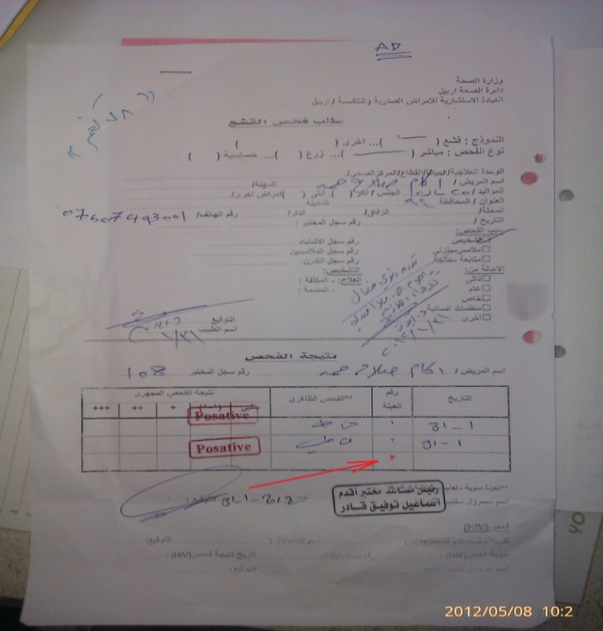
Erbil city center which is a TBMU caters to a population of 600,000 with 300-400 OPD attendance per day and is supported by 27 PHCC’s. TBMU is headed by a qualified Nephrologist who is the focal point of TB. TBMU has 3 pharmacists, 3 health workers and one laboratory technician. In spite of a well equipped laboratory and a trained laboratory technician, the TBMU laboratory has not been functional since more than a month because laboratory technician has stopped undertaking sputum microscopy for fear of contracting TB disease and the suspects are being referred to governorate RCDC clinic for sputum examination. The health worker and the pharmacists had a hostile attitude towards the TB treatment in general and DOTS in particular. One of their grouse was that TB patients in Erbil governorate RCDC speak to the pharmacy only through microphone and because of absence of microphone in this center they are directly exposed to TB patients. The focal point felt that location of his consultation chamber in the outpatient department between pediatric and gynecology OPD was not conducive to infection control.
Old forms and registers being used

73 TB patients (26 SS+, 27 SS - and 20 EP) were registered under treatment at Erbil City Center but none of them was taking treatment from this center. Only 7 TB cases were sent for HIV testing and no report was available.

The focal point who has been trained only last week advocated examination of 3 sputum samples -1 in the morning, 1 before breakfast and another after breakfast. This by itself raises a big question mark on the quality of training provided. Old forms and register indicating 3 sputum samples to be tested were being used. An 18 year male with TB No.50/ 12 weighing 99 KG was diagnosed sputum smear positive TB and all his smears were done in one day which is not the standard procedure. TB register indicated both samples of this patient positive while the laboratory report indicated one sample positive and another negative raising doubt on the quality of the laboratory. The team could not contact this patient. Pharmacy has a small sub-window for dispensing the drugs to the TB patients and the patients are not allowed to enter the pharmacy. DOTS is nonexistent. From the markings in the treatment cards, it’s also clear that the drugs are issued for one month. TB number 34/12, a 57 years old male, diagnosed as sputum positive on 17 February, 2012 indicates a follow up sputum examination on 12 April, 2012, but no sputum examination result has been indicated in the treatment card. Lymphadenitis is recorded as the diagnosis in the TB register for TB number 280/12, a 70 years male while the diagnosis in the TB card was shown as military TB. All these clearly show that quality of record keeping was poor.
No follow up sputum examination result indicated

Injection Streptomycin has not been available in the center for the last 3 months and no HRZE kits are available.

Nazdar Bamery PHC

All the 73 patients under treatment at City Center were referred to nearest PHCC. In Nazdor Bamery PHC, 12 TB patients were reported to be under treatment:

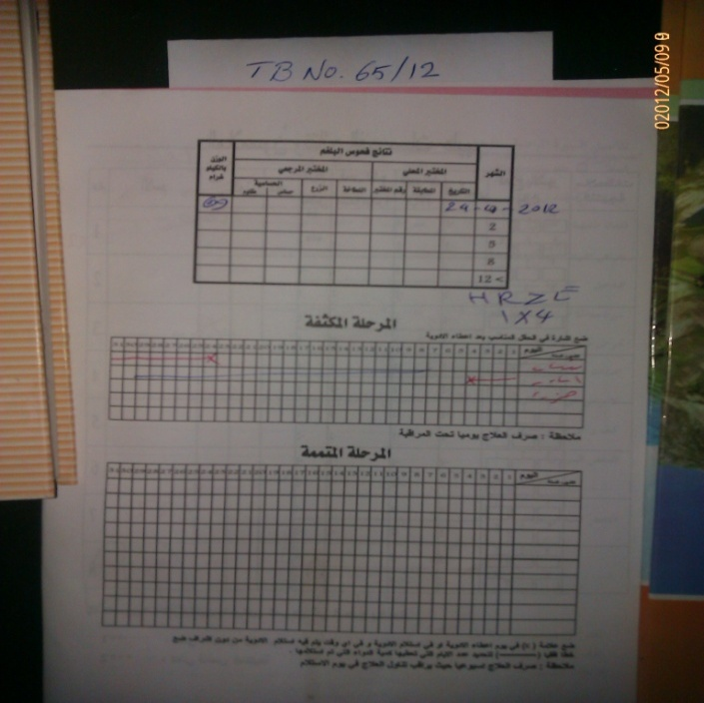
- TB No. 44/12, a 50 years female, diagnosed as category II was referred from Erbil city center on 3rd April, 2012, but the patient never came to this PHC and no default retrieval action was taken. Intensive Phase drugs for 7 weeks were available in a plastic bag containing the patient record.
TB No.65/12
- TB No. 65/12, a 49 years male, referred from city center started anti TB treatment from 24th April, 2012. No sputum test result has been recorded in the patient card. The patient was given drugs for 10 days at city center and after 4th May no indication of treatment continuation is shown in the card and only 5 weeks of IP treatment was found in the plastic bag.
- TB No. 137/11, a 60 years female diagnosed as Sputum Smear negative refereed from Erbil center. Patient took IP treatment for 6 weeks and defaulted. Remaining drugs of IP treatment are available in the plastic bag. The treatment card is totally blank.
- TB No. 89/11 a 17 year female diagnosed as Sputum smear positive and refereed from Erbil governorate was given 59 doses of IP starting from 30th March, 2011. CP started on 1st June and after 31st June the card is blank. The plastic bag doesn’t contain any medicines.
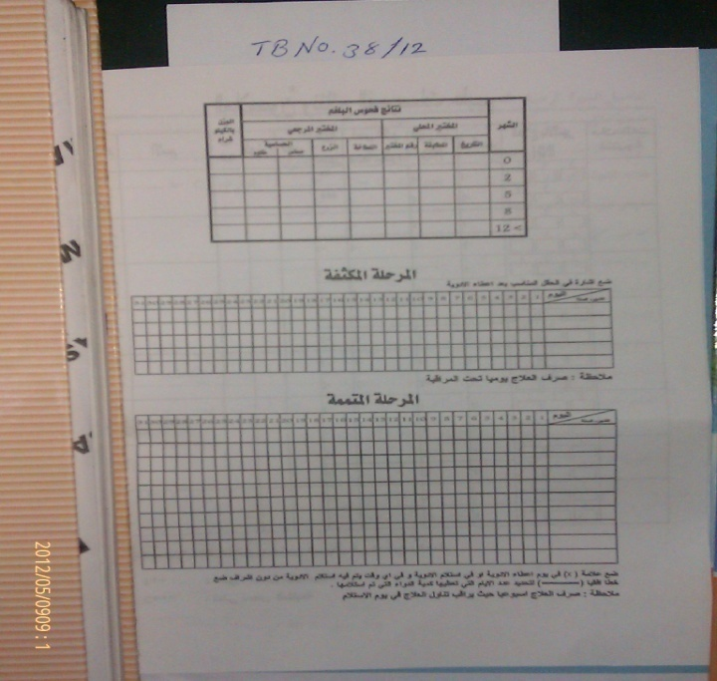
- TB No. 38/12 is 22 years male diagnosed as SS-. Treatment was initiated on 23rd Feb, 2012. Patient treatment card was blank and seven weeks IP treatment was available in the plastic bag.
TB No.38/12
- No follow up sputum result was recorded in TB register for TB No. 5/11, 40 years male diagnosed as sputum smear negative TB on 17th November, 2011. Continuation phase medications were marked for 10 days and 5 weeks continuation phase treatment was available in the bag.
- TB No. 49/11 is 70 years female, who has been diagnosed as SS- TB and started treatment on 18th Dec, 2011. Diagnostic and follow up smear was not recorded. IP treatment completed on 23 March .CP treatment marked from 3rd – 13th April and beyond that till 8th May, 2012 – the date of the visit of evaluation team, the card was blank. CP drugs for 2 weeks were available.
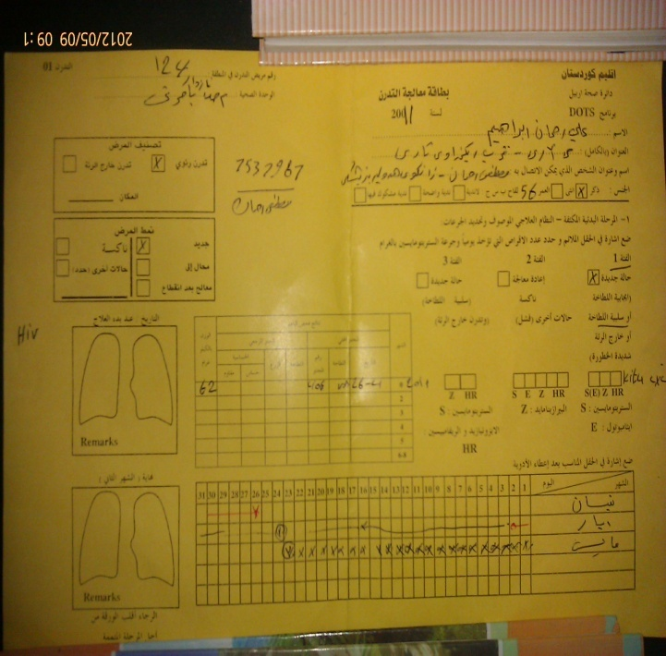
- TB No.1/11 of city center was SS- female (age not given). Treatment was started on 22nd Nov, 2011. CP treatment marked till 30th April, 2012. CP treatment is still due for 3 more weeks but no drugs were seen in the bag for the patient.
TB No.124/11
- TB No. 124/11, a 56 year sputum smear negative male started his treatment on 26th April, 2011. Took IP for 3 weeks. The patient card was not marked nor was any medicine available in the bag.
- TB No. 290/10, a 23 years male started the treatment on 29th Oct, 2010. Result of follow up sputum on 6th Feb, 2011 was not recorded on patient treatment card. IP treatment was marked for 2 weeks. CP treatment marked for 2 months till 10th April, 2011 and CP drugs for 3 weeks were available in the bag.
- TB No. 326/11, a 50 years sputum smear positive female stared the treatment on 1st Nov, 2011 and defaulted after one month. The same patient was registered as a fresh new case on 3rd April, 12 at Erbil TB center with TB NO.44/12. No drugs were available in the bag.
- TB No. 42/11, a 79 years old female, diagnosed as EPTB and started treatment on 13th Dec, 2011. CP marked from 3rd Feb. - 7th April, 2012. No drugs were available.

The health worker of Nazdar Bamery PHC was not aware of updated status of any of these 12 cases, none of which took regular treatment. None of the TB cards were properly marked nor contact tracings were recorded and the drugs were not fully accounted for. The clinic in-charge was totally unaware of the happenings in this center. There is no TB related health educational material available either in the center for distribution among the patients’/ attendants or displayed in the center. To say the least, DOTS strategy in the Nazdor Bamery PHC did not exist.

Recommendations:
- Drugs during IP should not be given for more than a week and first dose of every week should be facilitated by the health worker
- DOT should be made the standard of TB care and DOTS should be accepted and adopted by all health professionals working in the governorate
- A comprehensive defaulter retrieval policy in consultation with TBMU’s should be formulated and implemented
- Contact tracing should be implemented as a part of DOTS strategy and screening of contacts of infectious cases ensured, if required, through home visits, the journey for which should be facilitated by NTP
- Drug management system needs to be streamlined
- Diagnostic algorithm should be religiously adopted by all health care providers
- The governorate must adopt the cohort reporting pattern of central level
- Practice of speaking through microphone and distribution of drugs through pigeonhole should be stopped and the patient should be treated with respect.

